o’ cONNORS Pet Limited report

This is a report of a pet company who’s whole business planning and strategy has been introduced to technology to help pick up their sales, purchasing and nominal ledgers

Mayowa Bakare student number – 14503817

***Problems and weaknesses of current system***

**Sales & Marketing**

* No specific employee with the required skills assigned as a sales rep.
* No marketing.
* Poor analysis of competitors.
* No signs of advertising as company doesn’t even use internet.
* No marketing strategy.
* No anticipation of customer needs.
* Lack of customer profiling
* No skilled marketing and sales manager.
* No data of customers past orderings to analyse sales and market to find out what product are popular
* Credit terms need to be improved 30 days usually
* Items in store are not arranged.

**Management**

* No distribution of task towards each employee
* Every employee does the same job.
* Poor layout to the store
* Only 5 employees
* No ideal goals of the company present.
* Poor planning and structure to the business .only orders items when customers request for it.
* Poor organisational structure
* No copy of orders list in case it get lost or disagreement with suppliers.
* Poor planning as to amount of items needed or how often orders will be placed.
* No skilled manager.

**Finance**

* Poor cash management.
* Lack of cash in business.
* Too much money spent on items not being bought
* Selling items at lower price leads not no maximising of profit.
* Lack of knowledge of importance of cash.
* Only getting back 65% of items cost.
* No credits agreed with customers and suppliers.
* Paying higher cost per item since there’s no planning of when and amount of items that needs to be ordered.
* Double orderings
* Poor cash flow
* No skilled financial manager.
* **No budget planning**

**Operations and Inventory**

* Poor stock control.
* Poor stock management.
* Double orderings.
* Poor production schedule of orders.
* Production is not cost effective.
* No production manager.
* Overstock
* Poor keepings of order records.
* Lack of products

**Customer service**

* Poor customer relations.
* No online contact with customers or suppliers.
* No record of customer accounts.
* No record of supplier accounts.
* They do help resolve customer complaints but not in time.
* No benefits for customers who have been loyal for long period of time.
* No record customer preferred products.

**Purchasing**

* Ordering at wrong times
* Create credit agreement with suppliers 30 or 60 days.
* Ordering 2 of the same products
* Bad management of supplier data.

**Research and development**

* Lack of Technology in business.
* Lack of awareness of benefits of technological aid in businesses.
* No research of how to expand in future
* No growth plans evident**.**

***Diagram of proposed system***

Section 2.

***Solution of current system***

The manager of O’Connor pet products can improve the system by employing more employees, this will allow them to give separate specific and day to day tasks to each individual instead of everyone doing the same tasks. They should set ideal goals for the organisation and plan with structure how .control of all they orders. They can also create and manage the credit terms with suppliers.

With goals set it then allows you to know how much time is going to be spent increasing marketing and sales. Methods for Customer analysis should be done to know what type of they have and ways to attract these customers such as advertising on social media and creating a website to increase customer base which ultimately will increase the sales. They should collect customer data to know what products are purchased most so they can anticipate customer needs which will increase sales also.

Increase in sales will leave finance department in a better position than they were. Finance section should create budget plans and set targets to increase profits and minimise their loss. Good sales and management will allow them to gain better control of cash flow so they’ll know the importance of cash.

With quality research and development they can find out the benefits of technology in all aspects of the business from finance to social media marketing assigning task and also to communicate with customers.

They can e-mail customers, which is a quick process and the customers can also email them also if they have enquiries. This is a much faster, easier and effective way instead of sending letters which can take a day or two or may never be received by the customer.

**Tasbooks Benefits**

With the entry level package Tasbooks being introduced to your business the current weaknesses in the systems can be handled and overcome very easily. The Tasbooks package gives you 2 accounting software and stock modules which can give you effective control of your business**. Tasbooks is designed for small- medium size start up or sole trader companies.** (Synergy Network, 2016)

**For your business Tasbooks provides you with a simple software which allows you to manage your company with a lot of ease and simplicity. With Tasbooks you can manage all accounts involved with your business. You can record all the cash coming in and out of the business, you are able to develop all sales and purchase invoices. You also can manage Vat returns and the whole entire business.** (Synergy Network, 2016)

**This package enables you to manage customer and supplier contact and information such as credit limits. You can also view who your best or top customers are with an ascending of sales of the most to the least amount. You can also do the same for your suppliers too.**

**You can also view the financial status of your business displaying key balances such as cash, total assets and liabilities and how much stock you have on hand. In operations you can view the amount of all your expenses, your incomes, the cost of all your sales, and calculates all your profits. For visuals there is a financial graph that shows analysis of assets vs liabilities, Cash flow, total cash balances, debtor’s trends and balances, your income trend, your creditors’ trend and balances, your stock trend and your stock trend and balances.** (Synergy Network, 2016)

**You can also get good accurate reporting’s through printing audit trails and trial balances for example here a trial balance for the year done for you. You can also see every single transaction done in your company also. There are reports on sales and sales orders, cash books and receipts. These are a lot of the benefits of the Tasbooks package and there is a guide of how to do some key functions such as implementing customer details and invoices in screenshot form. This is available in the appendices 1.1.** (Synergy Network, 2016)

**Trial balance.**

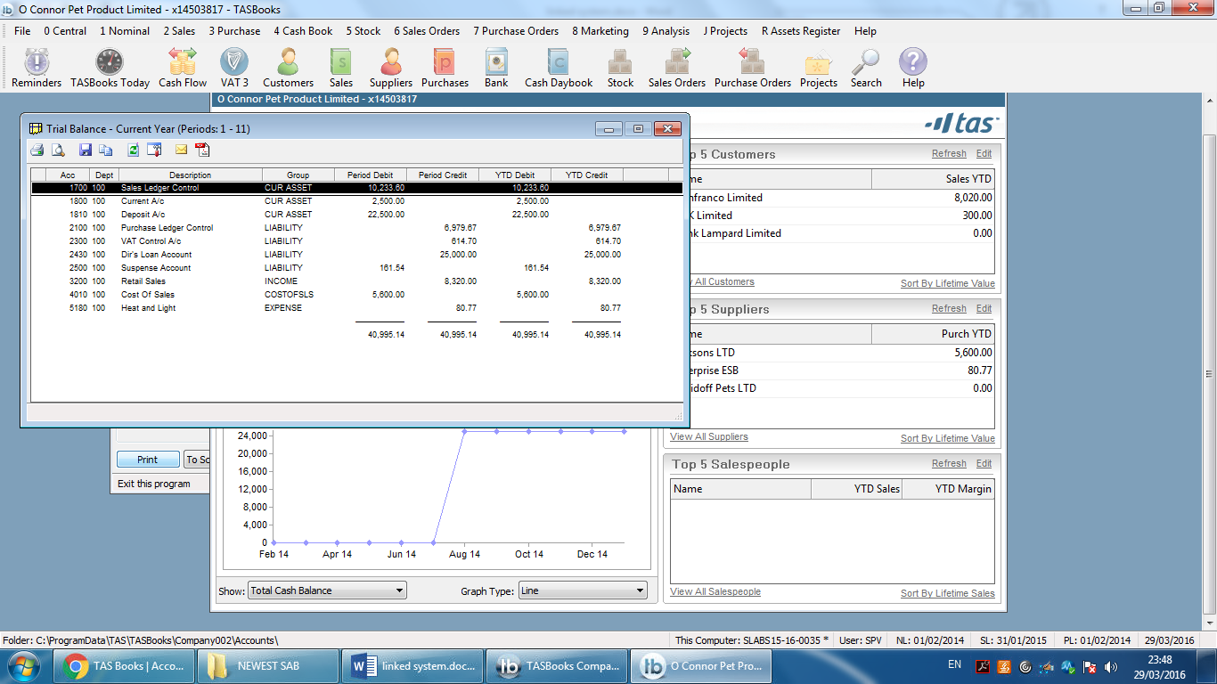

Audit trial.

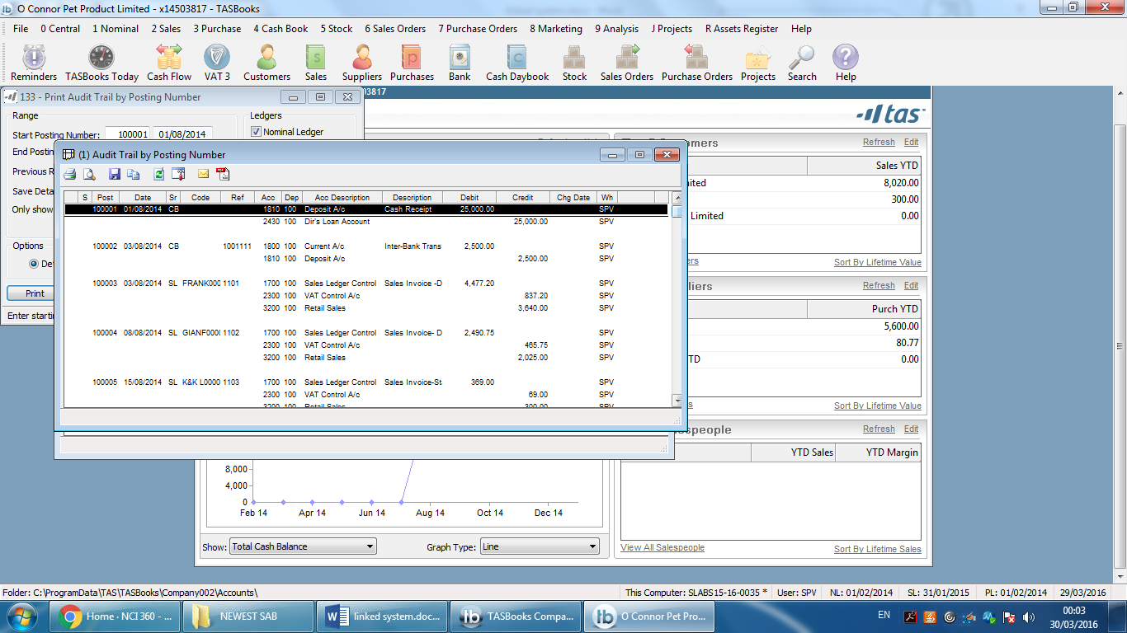

***Project Plan Section 3***

|  |  |  |  |  |  |  |  |
| --- | --- | --- | --- | --- | --- | --- | --- |
|  | ***O’Connor’s Pet Limited*** | |  |  |  |  |  |
|  |  |  |  |  |  |
|  | ***Click to view the Setup sheet.*** |  |  |  |  |  |  |
|  |  |  |  |  | ***in days*** | |  | | --- | |  | |
|  | ***week*** | ***Department section*** | ***Task*** | ***Assigned To*** | ***Est. Start*** | ***Est. Finish*** | ***Est. Duration*** |
|  |  |  |  |  |  |  |  |
|  | ***week 1*** | ***Managerial*** | ***Outline and the list of problems In the business.*** | ***Employee 1*** | ***08/01/2014*** | ***08/02/2014*** | ***1 day*** |
|  | ***week 1*** | ***Sales, Purchase, Finance*** | ***Contact and Gather all customer details and suppler details. Put €25000 into deposit account*** | ***Employee 5&2&4*** | ***01/08/2014*** | ***04/08/2014*** | ***3 days*** |
|  | ***week 1*** | ***Managerial*** | ***Staff Training*** | ***Employee 1*** | ***01/08/2014*** | ***10/08/2014*** | ***9 days*** |
|  | ***week 2*** | ***Managerial*** | ***set up internet and some purchasing packaging*** | ***employee1*** | ***06/08/2014*** | ***07/08/2014*** | ***1 day*** |
|  | ***week 2*** | ***inventory, Sales, Purchases ,Finance*** | ***Enter sales and purchase invoices. Transfer € 2500 from deposit to current account, buy stock*** | ***Employee 5&2&4&3*** | ***06/08/2014*** | ***08/08/2014*** | ***2 days*** |
|  | ***week 3*** | ***sales, Purchases*** | ***print credit notes and allocate receipts*** | ***Employee 5& 2*** | ***08/08/2014*** | ***08/08/2014*** | ***1days*** |
|  | ***week 4*** | ***managerial*** | ***Reorganise layout of store making it easy to find products.*** | ***Employee 1*** | ***13/08/2014*** | ***23/08/2014*** | ***10 days*** |
|  | ***week 5*** | ***inventory*** | ***take stock count, Place automatic order of stock once it reaches low amount and not when its sold out*** | ***Employee 3*** | ***20/08/2014*** | ***24/08/2014*** | ***4 days*** |
|  | ***week 6*** | ***financials*** | ***Maintain financial positon, give recommendations, manage cash, and create budgets.*** | ***Employee 4*** | ***01/09/2014*** | ***07/09/2014*** | ***6 days*** |
|  | ***week 7*** | ***managerial ,purchase, sales*** | ***From day to day reports and receipts, recognise most valuable products that sell the most and continue to order more of them so they don’t run out.*** | ***Employee 1,5,2*** | ***16/09/2014*** | ***19/05/2014*** | ***3 days*** |
|  | ***Week 8*** | ***financials, inventory, sales ,purchasing ,managerial*** | ***Produce and make a copy of all reports.*** | ***Employee 1,2,3,4,5*** | ***25/08/2014*** | ***30/08/2014*** | ***5 days*** |
|  | ***week 8*** | ***inventory , managerial*** | ***Take stock count again. Keep in contact with customers making a good relationship with them.*** | ***Employee 1&3*** | ***22/09/2014*** | ***26/09/2014*** | ***4 days*** |

**Project plan**

The above table is a copy of the business new project plan. The system is completed to have the sales purchases and nominal ledger running within 2 months.

Employees

Employee 1 – Frank also part owner – Manger

Employee 2 – David James – Sales.

Employee 3 – Sean Hughes – Inventory.

Employee 4 – Harvey James – Financials.

Employee 5 – Jack Banyan – Purchases.

The Excel Project Plan can be seen in the PDF file

***Robert Anthony 3 level decision making Section 4***

**Robert Anthony 3 level decision making model**

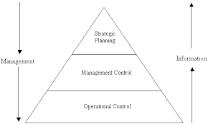(Munishwar, 2016)

Operational Control – is the planning of making sure that all specific task of the business are carried out effectively and efficiently. In the O’Connor’s pet system we will take some task for example taking the customers and suppliers from the paper based files and implementing them into the Tasbooks database. Tasbooks allows you to keep all details of customers and suppliers including invoices and any transactions in a database. Another task is to manage all the financial data like managing cash flows, sales, profits and assigning the most suitable person to keep all data in this field. (Munishwar, 2016)

All the data from this section allows the management / tactical control to take place as without the operations there wouldn’t be good data collected to be managed. In this section, based on the financial data collected you can begin making plans and properly have control of the business. All the trial balances sales, purchases and audit trail reports should be reviewed. From the reports exported from Excess files that you can locate in the appendences , scenarios such as “what can we do to improve sales”, “How can we increase customers” can be generated to help better the business and make plans as to what can be done to accomplish the plans made based on financial reports. This is possible as a benefit of Tasbook is being able to export reports to Excel. (Munishwar, 2016)

From tactical plans you to move to strategical control of the business. From your data and plans from the tactical planning you then develop strategical moves. Social media marketing. You can gain more customers marketing on Facebook and Twitter to gain more customers. You can develop a website so purchasing can be done online, this can gain understanding of customers, valued products/services, and gain competitive analysis. You can also get better understanding of the market. (Munishwar, 2016)

***Appendices 1.1***

**Section 2: Your proposed solution and benefits of your solution Tasbook**

Here are screenshots within the Tasbooks application which focuses on the company of O’ Connor Pet Products Limited. The screen shots show reports for sales, purchases and nominal ledger and how to accomplish each task step by step given to us to do.

**Entering Customers**

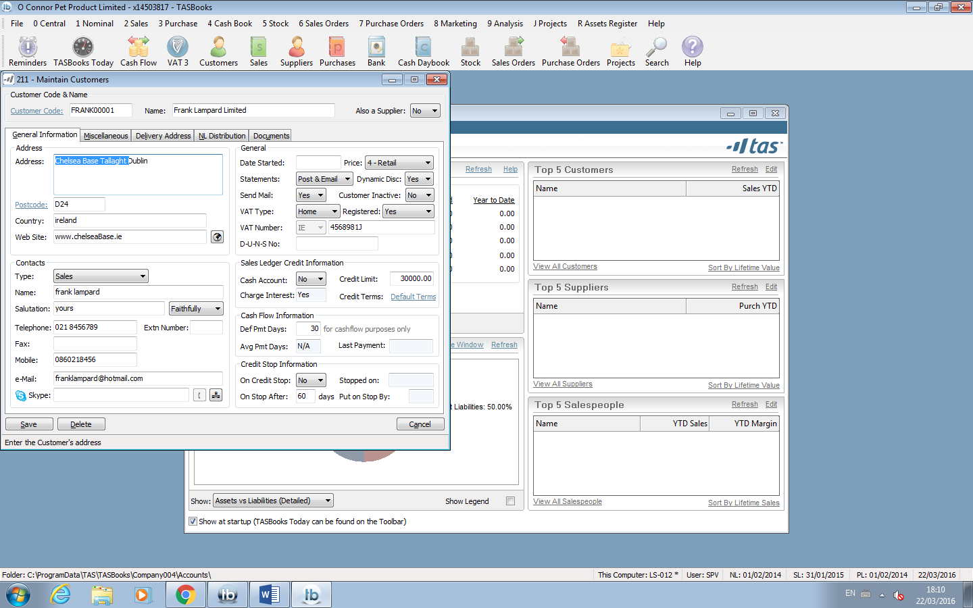The first step I did after creating the company into Tasbooks was creating and entering customer details of the company into the application. To do this you press ‘alt 211’ and the page where you can key in customer details comes up. Here I can enter the name, address and contact of customers. This is an example of one of the customers of the O’ Connor Pet Products Limited called Frank Lampard.

**Entering Suppliers**

The next thing you to do is create and enter your supplier details into the Tasbooks. To do this is very easy and similar to entering customer details. You click ‘ALT 311’ and the screen where you can enter supplier details comes up. You can enter Name, Contact details VAT and other additional information of your choice. To make an editor add more information to another supplier you simply click on supplier code choose your supplier, then type in any information you want then click save. The example of a supplier I have is Davidoff Pets LTD.

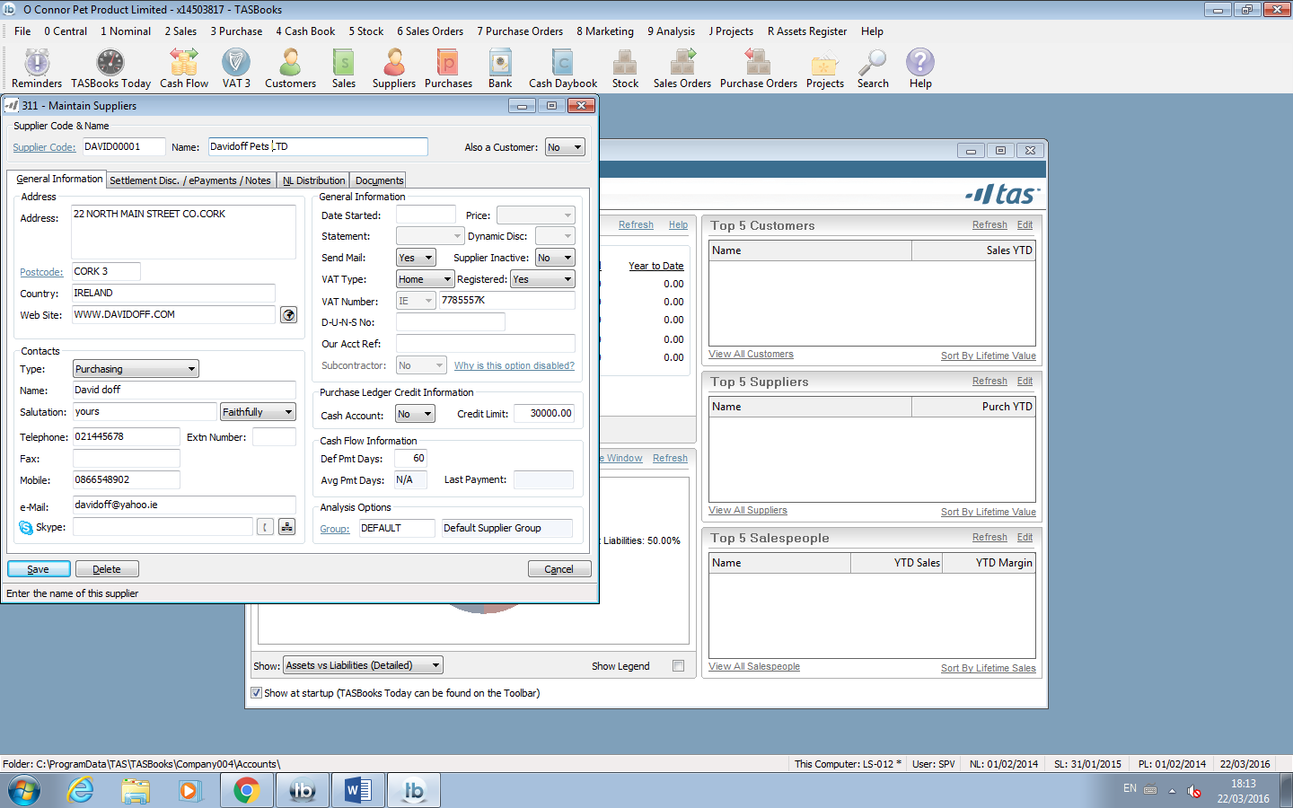

**Sales invoices**

Tasbook also allows you to enter the sales invoices of your customers. To do this you press ‘Alt 221’. When you have done this click on ‘code’ on the page that comes up and choose the customer you want to enter an invoice for. At this stage you can enter all the information of the invoice. Set your date and enter reference number then click 1 into the VAT which adds the VAT. Click on the tab button and your debits and credits will be calculated for you. On line 3 click F2 and again click account number ‘3200’ which is Retails sales and save.

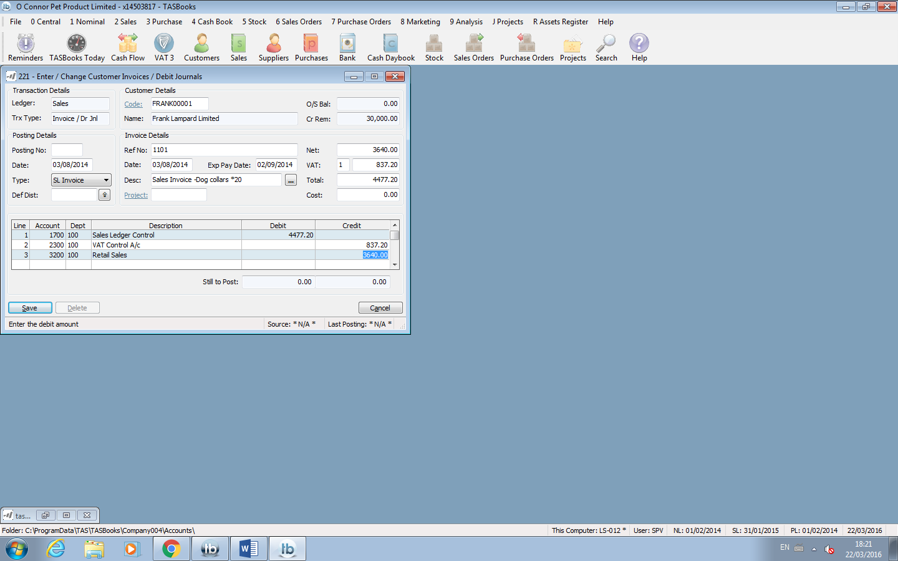

**Purchase invoices**

Also you can enter in purchase invoices for your suppliers, this is similar to entering sales invoices except you press ‘Alt 321’. When a page comes up click on ‘code’ and pick the supplier you want. In this case it’s ‘DAVID00001’. Edit the date to the required time, enter required reference number and enter the net value then press tab. Your debit and credit will be calculated for you then on the 3rd line click F2 and click on account number 4010 and then save.

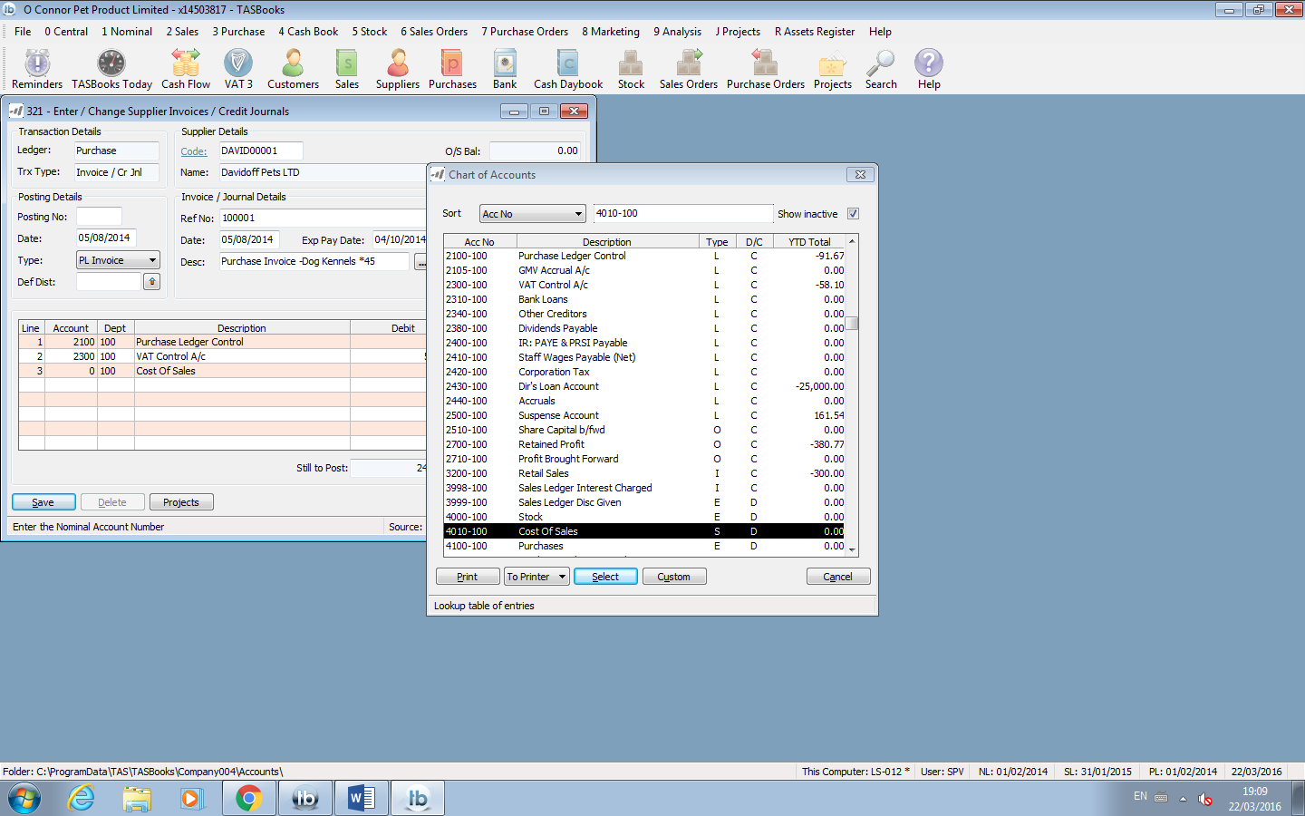

**Credit Notes**

After entering your invoices you can now enter your credit notes, which are similar to invoices. To enter a credit note press ‘Alt 222’ and click on ‘code’ to choose the customer you are entering credit notes for. Enter the relevant dates and a reference number starting with CN. Enter Net value and press tab till lines 1, 2, 3 have information in them. Press tab again and then save. This is a Credit note for customer Frank Lampard.

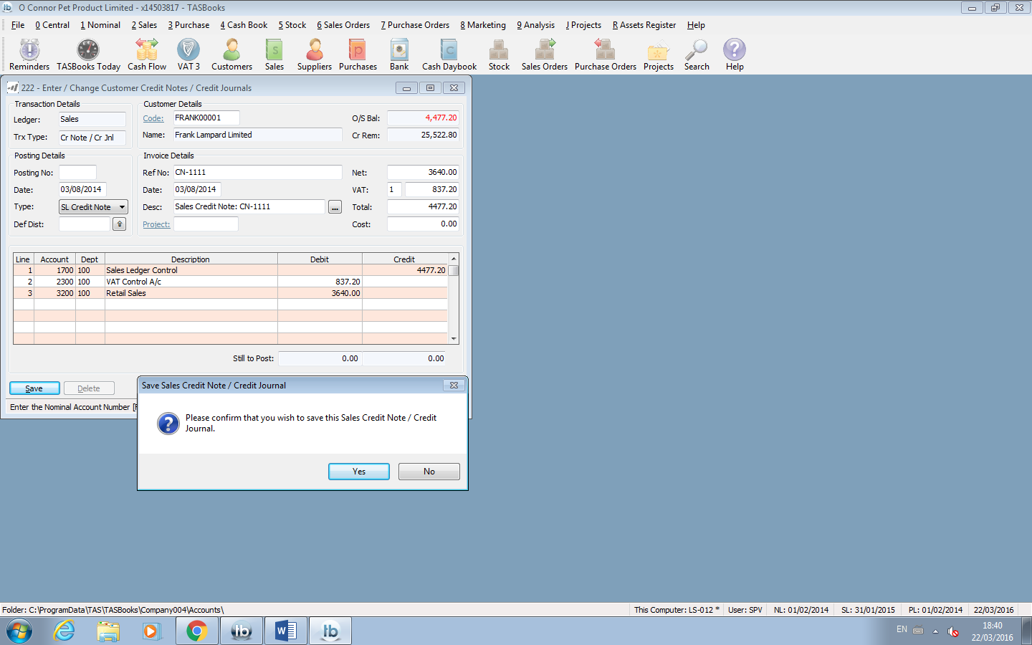

Purchase credit note

After entering your invoices you can now enter your credit notes, which are similar to invoices. To enter a credit note press ‘Alt 322’ and click on ‘code’ to choose the supplier you are entering credit notes for. Enter the relevant dates and a reference number starting with CN. Enter Net value and press tab till lines 1, 2, 3 have information in them. Press tab again and then save. This is a Credit note for supplier Frank Lampard.

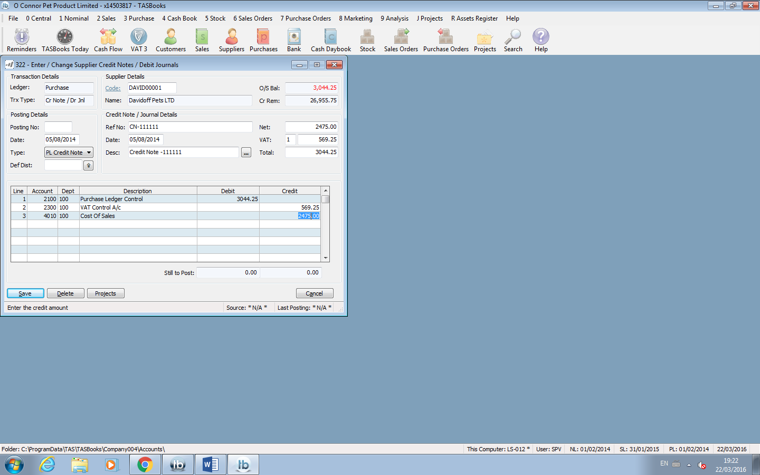

**Sales receipts**

Sales receipt tie in with credit notes and salves invoices. To avoid any future problems you should ensure the customers names and dates of sales invoice are the same. After entering credit notes and invoices you then need to allocate the sales receipts and to do this you press ‘Alt 251’. Click on ‘code’ and choose your company name then press tab. When you press tab the highlighted line in screenshot then appears. You then click tab again and the second screenshot page comes up which is asking which what way you want allocate your invoices. This is an allocation for Gianfranco Limited receipt.

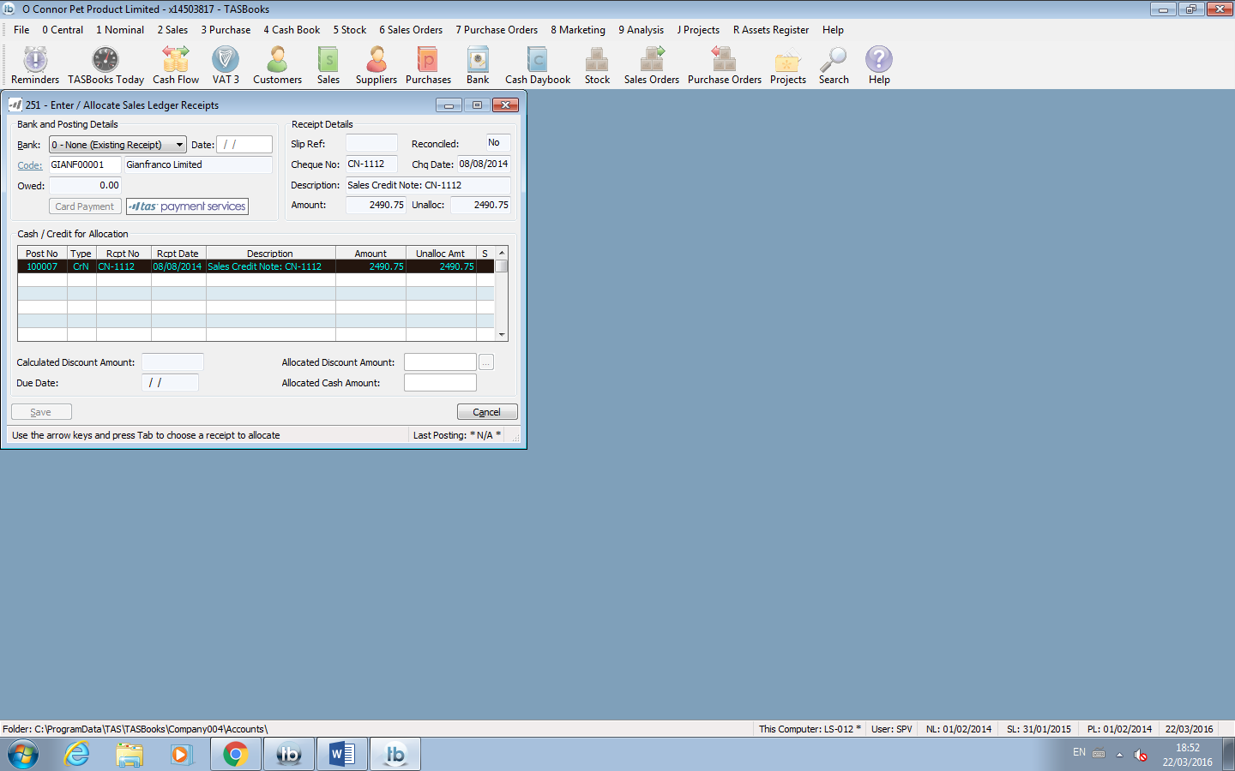

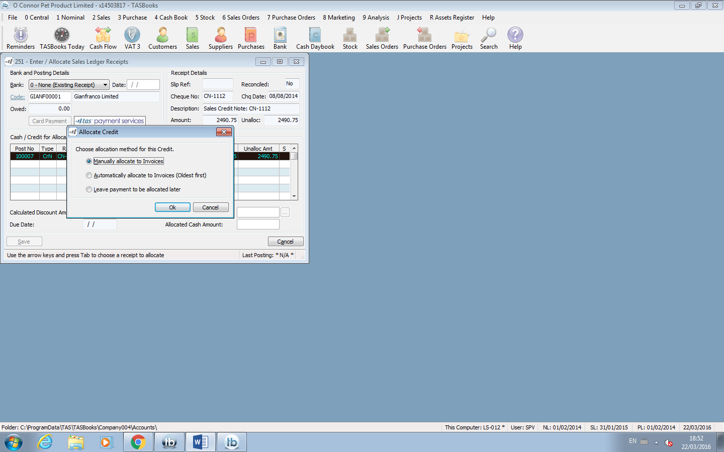

Purchase Payment

Purchase payment tie in with credit notes and purchase sales invoices. To avoid any future problems you should ensure the customers names and dates of sales invoice are the same. After entering credit notes and invoices you then need to allocate the purchase payment and to do this you press ‘Alt 351’. Click on ‘code’ and choose your supplier then press tab. When you press tab the highlighted line in screenshot then appears which unpaid invoices. You then click tab again and the second screenshot page comes up which is asking which what way you want allocate your invoices and save. This is an allocation for Davidoff Pets LTD.

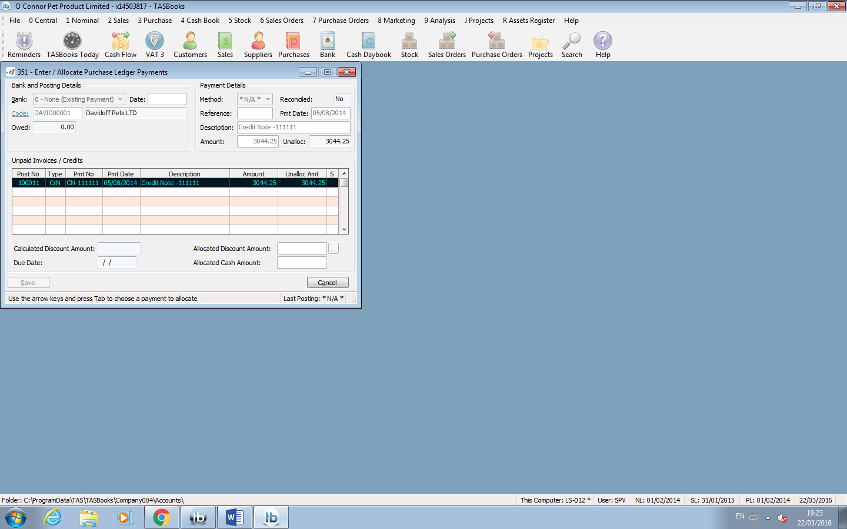

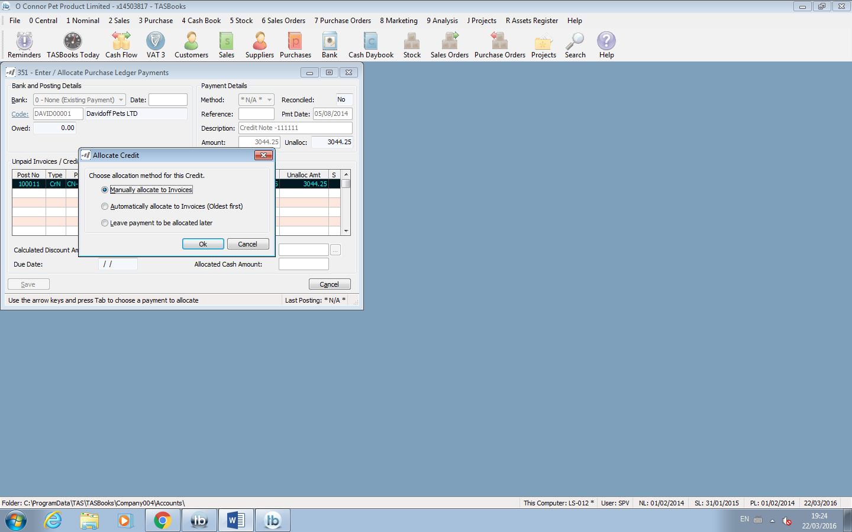

Transferring money from one account to another account.

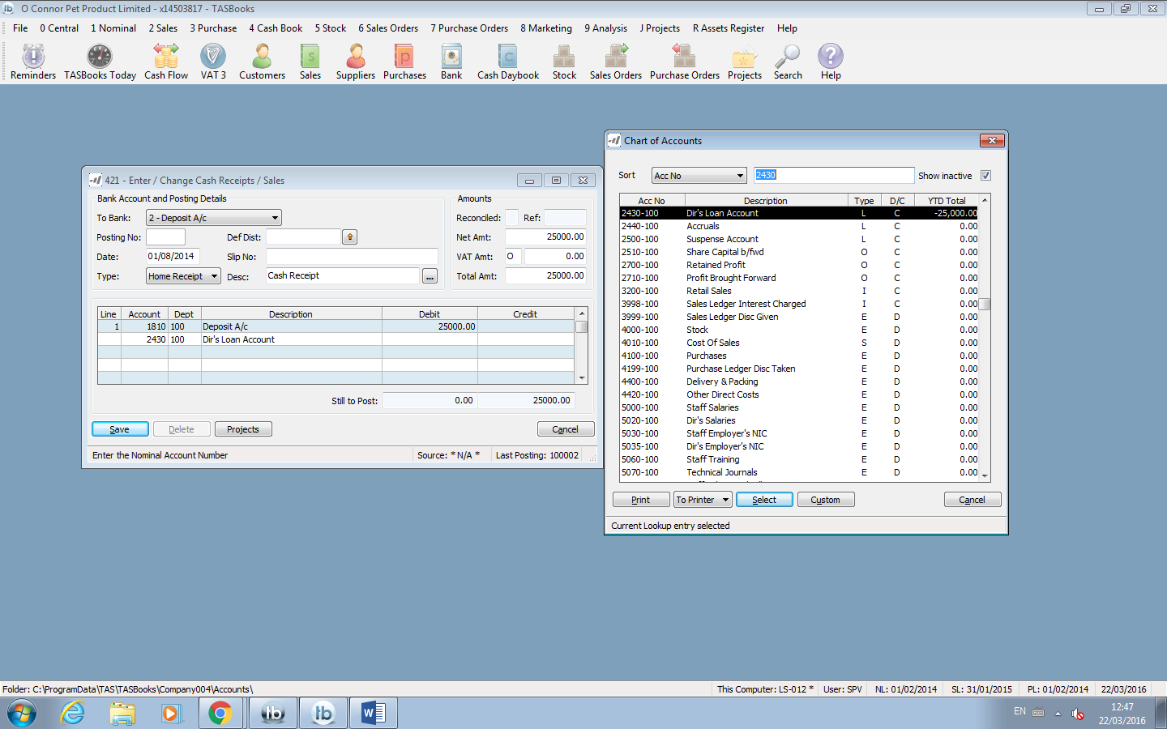In the tasks we are given that Frank has provided the company with a Director’s Loan and deposits €25,000 from his own funds into the Deposit Account on 1st August 2014. To do this within the application is very simple. You press ‘Alt 421’, a screen will then come up and beside “to bank” you click ‘”2- Deposit A/c”, then click on date and enter the date which in this case its “01/08/2014 “. On “Type” you click “Home Receipt” then put in the amount of €25000 in net amount, enter VAT as “O” and press tab button. On line 2 click F2 and click on account number “2430” then press tab again and click save.

**Transferring money from deposit account to current account.**

Maura (with Frank’s consent) transferred €2,500 of this amount from the deposit account into the current account on 3rd August using the lodgement reference 1001111.

****To do this is very simple and it’s a repeat of the task above. You press ‘Alt 421’ and this time change the bank to ‘1- Current account A/c’ , change the date to “03/08/2014”, change the type to “Inter- Bank”, enter Slip number as “1001111” and enter in net amount “2500”. You then press tab and I then clicked check-box for deposit account and clicked save.

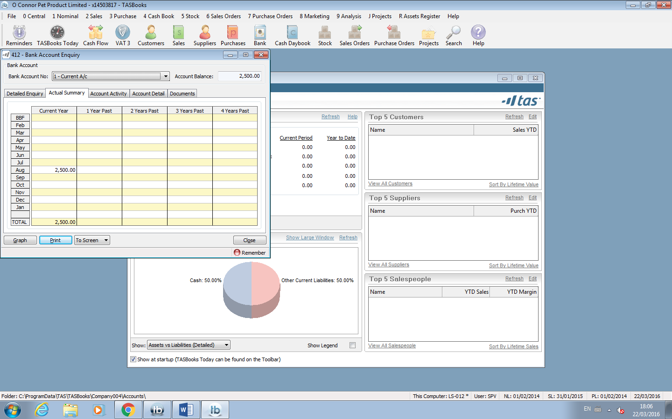To check if the money has been transferred click ‘alt 412’ then click on ‘Actual summary ‘ and the transaction should be there as in the screenshot.

Bibliography

Synergy Network. (2016). *TAS Books | Accounting | Payroll Software | Synergy Network*. [Online] Available at: http://www.synergynet.ie/product-range/tas-books/ [Accessed 5 Apr. 2016].

Munishwar, R. (2016). 1st ed. [ebook] Available at: http://mmumullana.org/downloads/mca%20content/MCA_305%20Managment%20Information%20System.pdf [Accessed 5 Apr. 2016].